Project Planning Phase
Project Planning Template (Product Backlog, Sprint Planning, Stories, Story points)

Date | 29 September 2026
Team ID | UNM111DJMRP
Project Name | AI FitTrack – AI-Powered Fitness Management and Recommendation System
Maximum Marks
Product Backlog, Sprint Schedule, and Estimation
Use the below template to create product backlog and sprint schedule
Sprint | Functional Requirement (Epic) | User Story Number | User Story / Task | Story Points | Priority | Team Members
Sprint-1 | Registration | USN-1 | As a member, I can register by entering my name, email and password. | 2 | High | Project Team
Sprint-1 | Login | USN-2 | As a member, I can log in with my email and password and receive a token. | 2 | High | Project Team
Sprint-1 | Authentication & Security | USN-3 | As a member, my protected requests are authenticated with a Bearer token so only I can see my data. | 3 | High | Project Team
Sprint-1 | Profile | USN-4 | As a member, I can view and update my fitness profile (age, height, weight, experience level, fitness goal). | 2 | High | Project Team
Sprint-1 | Workout Management | USN-5 | As a member, I can add a workout with name, category, duration, calories and date. | 3 | High | Project Team
Sprint-1 | Workout Management | USN-6 | As a member, I can view my own workouts, newest first, with pagination. | 2 | High | Project Team
Sprint-1 | Project Setup | USN-7 | As a developer, I can start the server, check /api/health and receive consistent JSON success and error responses. | 3 | High | Project Team
Sprint-1 | User Interface | USN-8 | As a member, I can use React pages for register, login and the dashboard. | 3 | Medium | Project Team
Sprint-2 | Workout Management | USN-9 | As a member, I can edit and delete my own workouts. | 3 | High | Project Team
Sprint-2 | Workout Management | USN-10 | As a member, I can search my workouts by text, name, category or date. | 2 | Medium | Project Team
Sprint-2 | Fitness Goals | USN-11 | As a member, I can create a fitness goal with a metric, target value and target date. | 3 | High | Project Team
Sprint-2 | Fitness Goals | USN-12 | As a member, I can view, update and delete my goals and see progress update automatically. | 3 | High | Project Team
Sprint-2 | Gym Attendance | USN-13 | As a member, I can check in when I arrive at the gym. | 2 | High | Project Team
Sprint-2 | Gym Attendance | USN-14 | As a member, I can check out when I leave the gym. | 2 | High | Project Team
Sprint-2 | Gym Attendance | USN-15 | As a member, I can view my attendance history filtered by date. | 2 | Medium | Project Team
Sprint-2 | User Interface | USN-16 | As a member, I can manage workouts, goals and attendance from React pages. | 3 | Medium | Project Team
Sprint-3 | Progress Analytics | USN-17 | As a member, I can see my progress summary: totals, category split, streaks and consistency. | 3 | High | Project Team
Sprint-3 | Progress Analytics | USN-18 | As a member, I can see week-by-week progress for the last N weeks. | 2 | Medium | Project Team
Sprint-3 | AI Recommendation | USN-19 | As a member, I can request an AI workout recommendation based on my profile, goals and recent workouts. | 5 | High | Project Team
Sprint-3 | AI Fitness Insights | USN-20 | As a member, I can get AI fitness insights from my own workout statistics. | 5 | High | Project Team
Sprint-3 | AI Reliability | USN-21 | As a member, I get a clear message if the AI service is busy, slow or not configured. | 3 | High | Project Team
Sprint-3 | User Interface | USN-22 | As a member, I can view progress, AI recommendation and AI insights pages in the web app. | 2 | Medium | Project Team
Sprint-4 | Admin Dashboard | USN-23 | As an administrator, I can view system-wide statistics on a dashboard. | 3 | High | Project Team
Sprint-4 | Member Management | USN-24 | As an administrator, I can see a members overview and open the details of any member. | 3 | High | Project Team
Sprint-4 | Member Management | USN-25 | As an administrator, I can view gym-wide workouts, goals, progress and attendance, filtered by member. | 3 | Medium | Project Team
Sprint-4 | Member Management | USN-26 | As an administrator, I can change a user's role or delete a user. | 3 | Medium | Project Team
Sprint-4 | Testing | USN-27 | As a tester, I can run automated tests and Thunder Client test cases for the whole API. | 3 | High | Project Team
Sprint-4 | Testing | USN-28 | As a member / administrator, I can take part in user acceptance testing and report bugs. | 3 | High | Project Team
Sprint-4 | Documentation | USN-29 | As a stakeholder, I can read the technical documentation and access the supplied project files. | 2 | Medium | Project Team

Project Tracker, Velocity & Burndown Chart: (4 Marks)
Sprint | Total Story Points | Duration | Sprint Start Date | Sprint End Date (Planned) | Story Points Completed (as on Planned End Date) | Sprint Release Date (Actual)
Sprint-1 | 20 | 6 Days | 07 Sep 2026 | 12 Sep 2026 | 20 | 12 Sep 2026
Sprint-2 | 20 | 6 Days | 14 Sep 2026 | 19 Sep 2026 | 20 | 19 Sep 2026
Sprint-3 | 20 | 6 Days | 21 Sep 2026 | 26 Sep 2026 | 20 | 26 Sep 2026
Sprint-4 | 20 | 1 Day | 28 Sep 2026 | 28 Sep 2026 | 20 | 28 Sep 2026

Velocity:
Velocity is the amount of completed story points per sprint. AI FitTrack planned and recorded 20 story points per sprint across four sprints (80 points total).
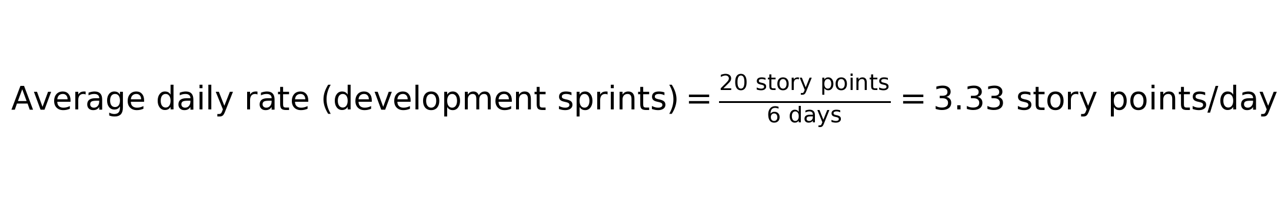
Recorded sprint velocity: 20 story points per sprint; 80 story points across four sprints.
For the three 6-day development sprints, the average daily rate is 20 story points ÷ 6 days = 3.33 story points per day. Sprint-4 was a separate 1-day closure sprint for admin, testing, UAT and documentation.

Burndown Chart:
A burn down chart is a graphical representation of work left to do versus time. It is often used in agile software development methodologies such as Scrum. However, burn down charts can be applied to any project containing measurable progress over time.
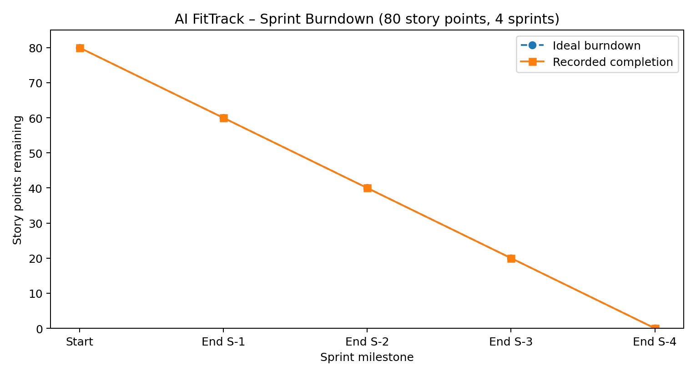
Ideal line: 80 → 0 story points across four sprints of 20 points. The planning table records 20 points completed in each sprint; Sprint-4 covered the admin module, testing, UAT and documentation.

https://www.visual-paradigm.com/scrum/scrum-burndown-chart/
https://www.atlassian.com/agile/tutorials/burndown-charts

Reference:
https://www.atlassian.com/agile/project-management
https://www.atlassian.com/agile/tutorials/how-to-do-scrum-with-jira-software
https://www.atlassian.com/agile/tutorials/epics
https://www.atlassian.com/agile/tutorials/sprints
https://www.atlassian.com/agile/project-management/estimation
https://www.atlassian.com/agile/tutorials/burndown-charts

